
PROJECT REPORT
Summer Training — Power BI
Formula 1 Race Performance Analytics Dashboard
Presented by
Krish Sharma | 2405039377
Course
B.Tech — Computer Science & Engineering
Institution
Chandigarh College of Engineering

1. Declaration
I hereby declare that the project report entitled “Formula 1 Race Performance Analytics Dashboard” submitted in partial fulfilment of the Summer Training Programme is an original piece of work carried out by me. The data used in this report has been collected from publicly available sources (Kaggle). The dashboards and visuals shown in this report have been independently created by me in Microsoft Power BI Desktop, with the supporting data cleaning and exploratory analysis carried out in Python.
I further confirm that this report or any part of it has not been submitted previously for any academic award.
Signature: ___________________________
Name: Krish Sharma
Date: 01 / 07 / 2026

2. Abstract
This project presents an interactive Formula 1 race performance analytics dashboard built in Microsoft Power BI, covering 75 seasons of racing history from 1950 to 2025. F1 fans, analysts, and broadcasters previously had no single place to explore this history — driver and constructor statistics were scattered across raw CSV files, making it difficult to compare eras, track reliability trends, or understand how grid position influences race results.
Six raw Kaggle datasets — races, results, drivers, constructors, circuits, and qualifying — containing over 26,000 rows and 21 key columns were cleaned, joined on driverId, constructorId, raceId, and circuitId, and merged into a single master table using Python and Power Query. Seven engineered features (including winner, podium, pole position, and positions gained) were added to support deeper analysis. Exploratory Data Analysis in Python examined driver dominance, constructor efficiency, reliability, and the relationship between qualifying and finishing position, before the cleaned dataset was loaded into Power BI.
The resulting multi-page dashboard uses KPI cards, bar charts, a line chart, a donut chart, and an area chart, with slicers for Constructor, Year, Driver, Country, and Circuit, to let users filter and explore 861 drivers, 211 constructors, 1,125 races, and 77 circuits interactively. Key outcomes include confirmation that Lewis Hamilton leads all-time wins with 105, that pole position converts to a win only 42.3% of the time, and that average finishing position rises steadily with starting grid position — evidence that strategy and reliability matter as much as raw qualifying pace.

3. Introduction

3.1 Background
Sports analytics is an increasingly data-driven domain, and Formula 1 is one of the most data-rich motorsports in the world, with detailed records of every race, driver, constructor, and circuit dating back to 1950. Despite this depth of history, raw F1 data is typically distributed as a collection of disconnected CSV files rather than a usable analytical view. Dashboards and business intelligence tools allow organisations — and, in this case, fans, analysts, and content creators — to convert raw historical records into visual, interactive insights that support faster comparison and decision-making, rather than relying on static spreadsheets.

3.2 Problem Statement
F1 fans, analysts, and broadcasters lack a single place to explore 75 years of race history. Driver and constructor statistics are scattered across raw CSVs, making it hard to compare eras, track reliability trends, or see how grid position affects results.
- Target users: F1 enthusiasts, content creators, and sports analysts who want a fast, visual way to explore historical race data instead of digging through raw spreadsheets.
- Previously unavailable: a unified, filterable view spanning all seasons, drivers, constructors, and circuits in one place.
- Easier decisions afterward: quickly comparing driver eras, identifying reliability and strategy trends, and benchmarking constructors by both raw wins and efficiency.

3.3 Objectives
- Clean and merge six raw F1 datasets (races, results, drivers, constructors, circuits, qualifying) into one master table.
- Engineer features such as winner, podium, pole position, and positions gained for deeper analysis.
- Run exploratory analysis on driver, constructor, and race-level trends using Python.
- Design an interactive multi-page Power BI dashboard with 8+ visual types.
- Surface clear, data-driven insights on driver dominance, reliability, and race strategy.
- Publish the final report to Power BI Service with working slicers and cross-filtering.

4. Dataset Description

4.1 Data Source
The dataset was sourced from Kaggle’s Formula 1 World Championship archive, comprising six CSV files spanning 1950–2025: races.csv, results.csv, drivers.csv, constructors.csv, circuits.csv, and qualifying.csv. Together these contain over 26,000 rows and were merged into a single master table joined on driverId, constructorId, raceId, and circuitId.

4.2 Key Fields / Columns
- races.csv — race calendar, year, round, circuit.
- results.csv — finishing position, points, status.
- drivers.csv & constructors.csv — driver and team names and details.
- circuits.csv — track name, location, country.
- qualifying.csv — Q1 / Q2 / Q3 session times.
The final master dataset retained 21 columns after merging and feature engineering, used throughout the EDA and dashboard stages.

4.3 Data Quality Issues & Cleaning Steps
- No duplicate rows found across races, results, drivers, constructors, or circuits.
- No missing values in races, results, drivers, constructors, or circuits.
- Qualifying contained 22 missing values in Q2 and 46 in Q3 (68 in total); these were retained, as they validly indicate drivers eliminated in earlier qualifying sessions rather than data errors.
- fastestLapSpeed nulls were retained, since speed data is genuinely unavailable for many historical races and retired drivers.
- The date column was converted from text to a proper datetime type to support time-based trend analysis.
- Redundant raw columns (resultId, time, milliseconds, rank) were dropped after merging to keep the master table lean.
- Seven new features were engineered (e.g., winner, podium, pole position, positions gained) and the cleaned result was exported as master_f1_dataset.csv for the EDA and dashboard stages.

5. Data Modelling

5.1 Schema Design
Rather than a multi-table star schema inside Power BI, the six source files were pre-joined in Python/Power Query into a single wide master fact table (one row per driver-race result), enriched with race, driver, constructor, and circuit attributes plus seven engineered flag columns. This denormalised approach keeps all 21 analytical fields in one place and simplifies slicer and DAX design for a dashboard of this scope.

5.2 Engineered Features
- winner — flags the race winner (finishing position 1).
- podium — flags top-three finishes.
- pole_position — flags drivers who started P1.
- positions_gained — difference between grid and finishing position.
- win_percentage / reliability-related fields used in constructor-level aggregations.
- Cleaned date / season fields used for time-based trend charts.

6. Dashboard & Visuals
The final Power BI report is a single, densely-filtered overview page covering the full 1950–2025 history, designed so a user can slice by Constructor, Year, Driver, Country, or Circuit using the panel on the left and see every visual update together.

6.1 Overview Page
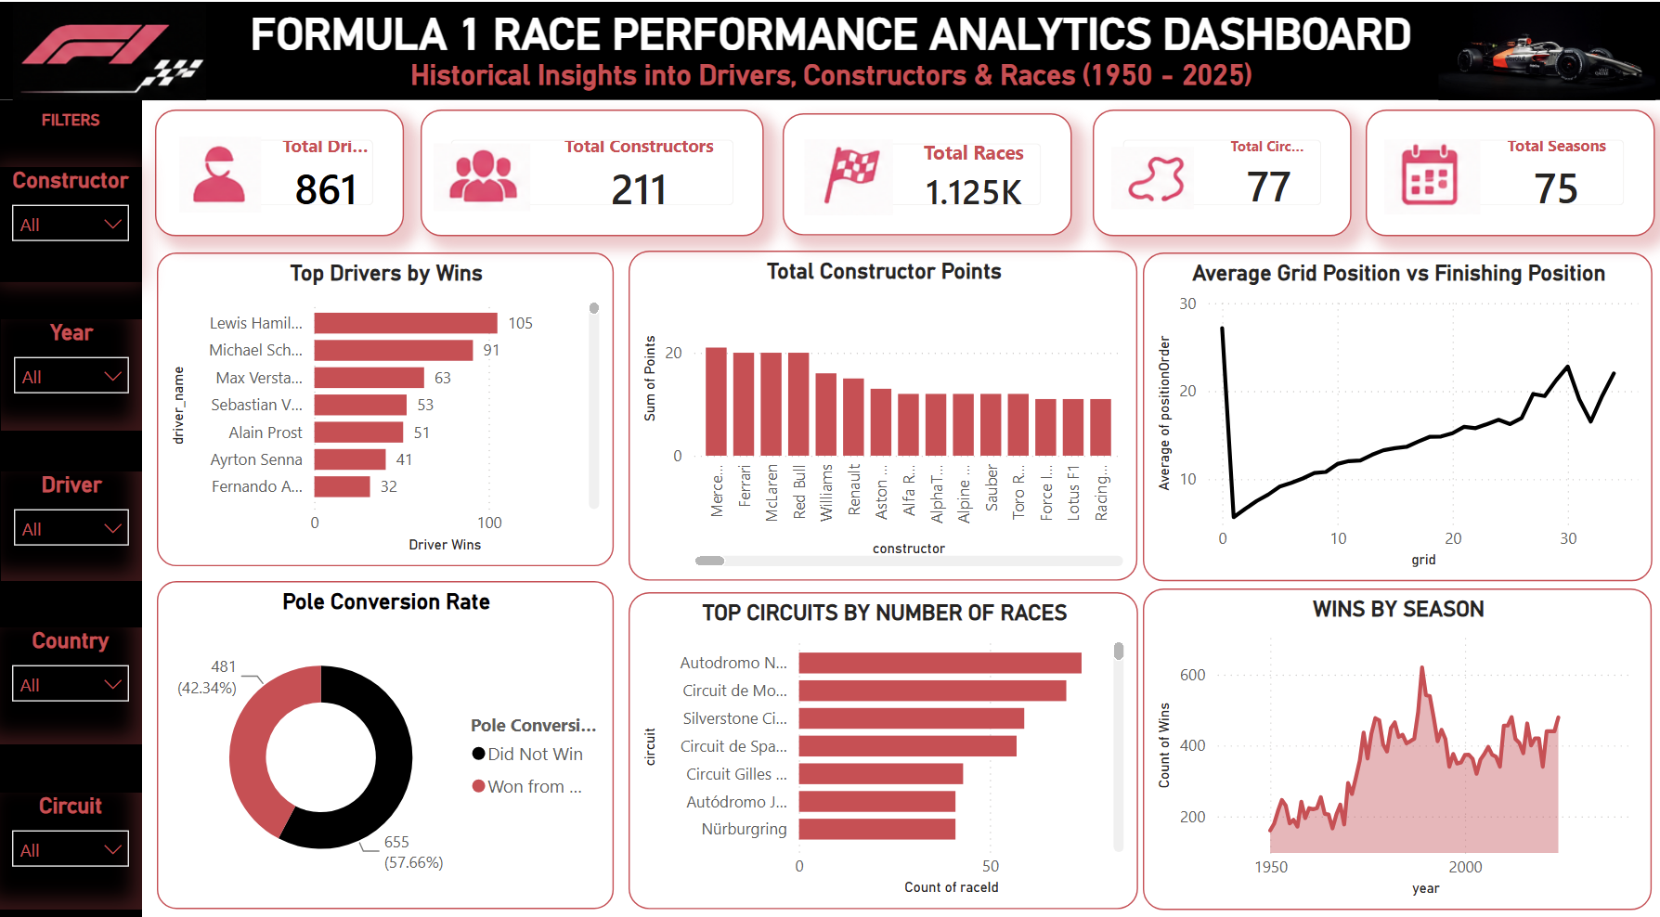
Visuals used on this page:
- KPI Cards — Total Drivers, Total Constructors, Total Races, Total Circuits, Total Seasons.
- Bar Chart — Top Drivers by Wins (Hamilton, Schumacher, Verstappen, Vettel, Prost, Senna, Alonso).
- Bar Chart — Total Constructor Points by team.
- Line Chart — Average Grid Position vs Finishing Position.
- Donut Chart — Pole Position Conversion Rate (won vs did not win).
- Bar Chart — Top Circuits by Number of Races.
- Area Chart — Wins by Season (1950–2025).
- Slicers — Constructor, Year, Driver, Country, Circuit.
Key insight from this page: one view spans 75 seasons (1950–2025) covering 861 drivers, 211 constructors, 1,125 races, 77 circuits, and 75 seasons, with pole position converting to a win 42.3% of the time — a clear signal that qualifying pace alone does not decide races.

7. Key Findings & Insights
- Lewis Hamilton leads all-time wins with 105, ahead of Michael Schumacher (91) and Max Verstappen (63), reflecting sustained dominance across different eras of the sport.
- Ferrari, Mercedes, and McLaren top the all-time constructor points table, but a separate win-percentage analysis shows that raw points leadership and per-entry efficiency favour different teams.
- Pole position converts to a race win only 42.3% of the time (481 of 1,136 races analysed in the conversion view), confirming that strategy, tyre management, and reliability matter as much as raw qualifying pace.
- Average finishing position rises steadily as starting grid position gets worse, confirming that qualifying performance still strongly shapes race outcomes even though overtakes and incidents add variance.
- Autodromo Nazionale Monza, Circuit de Monaco, and Silverstone Circuit host the most Grands Prix among all 77 circuits in the dataset, underlining how a handful of historic venues anchor the F1 calendar across 75 seasons.

8. Learnings & Challenges

8.1 Skills Learned
- Connecting to and transforming raw multi-file CSV data using Python (pandas) and Power Query.
- Joining six related tables on shared keys (driverId, constructorId, raceId, circuitId) into a single analysis-ready master table.
- Engineering derived flags (winner, podium, pole position, positions gained) directly from raw grid and finishing data.
- Designing a multi-visual Power BI overview page with KPI cards, bar, line, donut, and area charts driven by shared slicers.
- Distinguishing genuinely missing data (e.g., qualifying nulls, unavailable lap speeds) from data quality errors, and deciding when to retain versus clean values.

8.2 Challenges Faced
- Reconciling inconsistent identifiers across the six source files required careful key selection before merging, to avoid duplicated or dropped rows.
- Deciding how to treat nulls in the qualifying data (Q2/Q3) required understanding the racing context — these nulls were valid (drivers eliminated early) rather than data errors, so they were retained instead of imputed.
- Building a single overview page dense enough to answer driver, constructor, and circuit-level questions at once required careful layout and visual selection to avoid overcrowding.

9. Conclusion
This project successfully demonstrates an end-to-end analytics workflow — from six raw F1 CSV files, through Python-based cleaning and feature engineering, exploratory data analysis, and finally an interactive Power BI dashboard. The dashboard directly addresses the original problem statement: it gives F1 enthusiasts, analysts, and content creators a single, filterable view of 75 seasons of racing history, in place of scattered raw spreadsheets. The most significant finding — that pole position wins only 42.3% of the time — reinforces the value of the dashboard in surfacing insights about strategy and reliability that are not obvious from raw results alone.
Given more time, the project would benefit from adding lap-by-lap telemetry and weather data, building predictive models for race outcomes, and introducing a dedicated drill-through page for individual driver or constructor profiles. This training experience strengthened practical data cleaning, DAX, and dashboard design skills, and provided hands-on exposure to the business intelligence workflow used in industry.

10. References
- Microsoft Power BI Documentation — https://docs.microsoft.com/en-us/power-bi/
- Dataset Source — Formula 1 World Championship (1950–2025), Kaggle.
- DAX Reference Guide — https://dax.guide/
- Power Query M Reference — https://docs.microsoft.com/en-us/powerquery-m/
END OF REPORT

